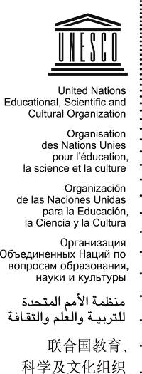 | Intangible Cultural Heritage 2 COM
 | Distribution Limited | ITH/07/2.COM/CONF.208/15  Paris, 6 June 2007  Original: English

UNITED NATIONS EDUCATIONAL, SCIENTIFIC
AND CULTURAL ORGANIZATION

INTERGOVERNMENTAL COMMITTEE
FOR THE SAFEGUARDING OF THE INTANGIBLE CULTURAL HERITAGE

Second Session
Tokyo, Japan, 3 to 7 September 2007

Item 15 of the Provisional Agenda: Date and place of the next session

Decision required: paragraph 2

- In conformity with Rule 4 of its Rules of Procedure, the Committee shall determine at each ordinary session, in consultation with the Director-General, the date and place of its next session.
- The Committee may wish to adopt the following draft decision:
DECISION 2.COM.15
The Committee,
- Having examined the proposal of […] to host its third ordinary session;
- Decides to hold its third ordinary session in […], in [September][November] 2008;
- [Having examined the proposal of […] to host its second extraordinary session in early 2008 in […];
- [Decides to hold its second extraordinary session in late February 2008 in […].

