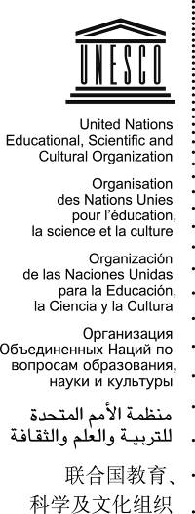 | Intangible Cultural Heritage 2 EXT COM
 | Distribution Limited | ITH/08/2.EXT.COM/CONF.201/2  Paris, 15 October 2007  Original: French

UNITED NATIONS EDUCATIONAL, SCIENTIFIC
AND CULTURAL ORGANIZATION

INTERGOVERNMENTAL COMMITTEE
FOR THE SAFEGUARDING OF THE INTANGIBLE CULTURAL HERITAGE

Second Extraordinary Session
Sofia, Bulgaria, 18 to 22 February 2008

Item 2 of the Provisional Agenda: Election of the Members of the Bureau of the second extraordinary session of the Committee

Summary
In accordance with Rule 13.2 of the Committee’s Rules of Procedure, in case of an extraordinary session, the Committee shall elect a Chairperson, one or more Vice-Chairperson(s) and a Rapporteur who shall remain in office until the end of that session. This document proposes a draft decision for doing so.
Decision required: paragraph 3

- In accordance with Rule 13.2 of the Committee’s Rules of Procedure, in case of an extraordinary session, the Committee shall elect a Chairperson, one or more Vice-Chairperson(s) and a Rapporteur who shall remain in office until the end of that session. The Committee therefore needs to elect its Bureau for this second extraordinary session. In electing the Bureau, the Committee shall have due regard to the need to ensure equitable geographical representation and, inasmuch as possible, maintain a balance among the various fields of the intangible cultural heritage (Rule 13.4). Nothing in the Rules of Procedure would exclude the possibility that one or more member(s) of the Bureau elected at the end of its second session would be elected to serve as members of the Bureau of the second extraordinary session.
- The Committee may wish to adopt the following draft decision:
DRAFT DECISION 2.EXT.COM 2
The Committee,
- Elects * * * (Name/State Member) as Chairperson of the second extraordinary session of the Committee,
- Elects * * * (Name/State Member) as Rapporteur of the second extraordinary session of the Committee,
- Elects * * * (State Member), * * * (State Member), * * * (State Member) and * * * (State Member) as Vice-Chairpersons of the second extraordinary session of the Committee.

