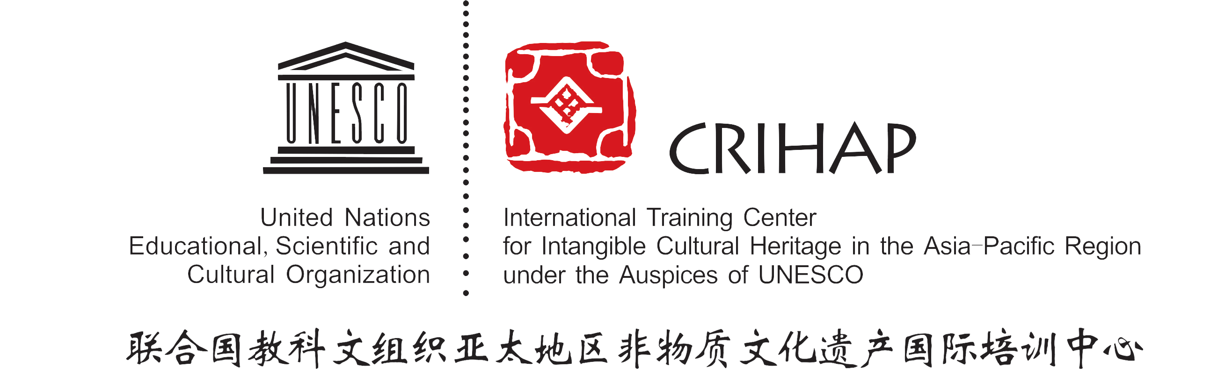
CRIHAP/2013/2.GB/4
Chengdu, 17 June 2013

INTERNATIONAL TRAINING CENTER
FOR INTANGIBLE CULTURAL HERITAGE
IN THE ASIA-PACIFIC REGION UNDER THE AUSPICES OF UNESCO
(CRIHAP)

GOVERNING BOARD

The 2nd Session
Chengdu, China
17 June 2013

Item 4 of the Provisional Agenda
Examination of the Report on the Work and Final Accounts of
CRIHAP in 2012

Decision required：paragraph 3

- As per Article 8.2 of the Agreement, the Governing Board shall examine the annual reports submitted by the Director of the Center.

- The Report on the Work and Final Accounts of CRIHAP in 2012 (February 2012 to May 2013) is contained in the annex.

- The Governing Board may wish to adopt the following decisions:
DRAFT DECISION GB/4
The Governing Board,
1．Having examined document CRIHAP/2013/2.GB/4 and its annex;
2．Adopts the Report on the Work and Final Accounts of CRIHAP in 2012.
Annex
The Report on the Work and Final Accounts of CRIHAP in 2012

From February 2012 to May 2013, at the first stage after its official establishment and beginning of operation, CRIHAP realized its goal for development, which is to start operation and to advance gradually, by way of international training, international exchange and cooperation, international conference, organizational construction, and other logistic works (such as office space rental & office supplies purchasing) ensuring the smooth operation. Thus, a stable basis for future works has been established.

In order to sum up our experience and forge ahead, we hereby would like to make the following report on our work from February 2012 to May 2013:

- The Inaugural Session of the Governing Board of CRIHAP and the Inaugural Ceremony of CRIHAP:
On 22 February 2012, the Inaugural Session of the Governing Board of CRIHAP and the Inaugural Ceremony of CRIHAP were held, proclaiming the official establishment and beginning of operation of CRIHAP.

- International Conferences:
In accordance with Article 7.4 of the Agreement, it’s one of the objectives of CRIHAP to ‘foster regional and international cooperation for safeguarding ICH’. During the period from February 2012 to May 2013, CRIHAP greatly promoted the realization of this objective by way of hosting and organizing international conferences as follows.
  - February 2012, CRIHAP held the International Information Session on ICH Safeguarding;
  - August 2012, In cooperation with ASEAN-China Centre and China National Center for the Safeguarding of the Intangible Cultural Heritage, CRIHAP organized the Seminar on Safeguarding the Intangible Cultural Heritage in ASEAN & China;
  - November 2012, in cooperation with UNESCO, CRIHAP organized the Review Meeting of UNESCO’s Global Strategy for Strengthening National Capacities for Safeguarding Intangible Cultural Heritage;
  - January—May 2013, in cooperation with the Ministry of Culture, People’s Republic of China, Chinese National Commission for UNESCO, and UNESCO, CRIHAP took part in the organizing and preparative works for the Chengdu International Conference on Intangible Cultural Heritage in Celebration of the Tenth Anniversary of UNESCO’s Convention for the Safeguarding of the Intangible Cultural Heritage.

- International Exchange and cooperation:
As an international institution under the auspices of UNESCO in the field of intangible cultural heritage, CRIHAP carries out its works under the Convention for the Safeguarding of the Intangible Cultural Heritage, and carries out its exchange and cooperation with other centers and related international organizations.
  - participation in international conferences organized by UNESCO
- June 2012, participation in the 4th Session of the General Assembly of the States Parties to the Convention for the Safeguarding of the Intangible Cultural Heritage;
- October 2012, participation in the Open ended Intergovernmental Working Group on the Right Scale or Scope of an Element;
- December 2012, participation in the 7th Session of the Intergovernmental Committee for the Safeguarding of the Intangible Cultural Heritage of UNESCO;
  - Participation in the working meetings held by other C2 centers:
- April 2012, participation in the Meeting of Category II Centers for Intangible Cultural Heritage in the Asia-Pacific Region held by UNESCO Bangkok Office;
- October 2012, participation in the 2nd Session of the Governing Board of ICHCAP;
  - Participation in international workshops organized by UNESCO
November 2012, participation in Capacity Building Workshop on the Implementation of the 2003 Convention at the National Level organized by UNESCO in Ulaanbaatar, Mongolia;
  - Receiving visitors from other international institutions:
- March 2012, receiving successively visiting group headed by Ms Beatrice KALDUN, official from UNESCO Beijing Office and visiting group headed by Mr. Shahin MUSTAFAYEV, Director of the International Institute for Central Asia Studies in Uzbekistan (IICAS, Category 2);
- May 2012, receiving visiting group headed by Dr. Witaya JERADECHAKUL, Director of the SEAMEO Secretariat;
- January 2013, receiving visiting group headed by Ms Beatrice KALDUN, official from UNESCO Beijing Office.

- International Training:
It’s the core function for CRIHAP to organize international training for ICH and thus to enhance the capacity of ICH safeguarding in related countries in the Asia-Pacific region.
  - December 2012, CRIHAP held the Workshop on the Implementation of the 2003 Convention at the National Level. With implementation as the subject of the workshop, CRIHAP invited UNESCO accredited facilitators conducting training courses for experts and officials in the field of ICH from countries and territories in the Pacific region.
  - February—May 2013, suggested by facilitators, CRIHAP prepared for an international workshop on inventorying for the trainees from the Pacific region.

- Organization Construction:
  - Establishing the Advisory Committee and organizing the 1st Session of the Advisory Committee. In accordance with the relating decisions, CRIHAP established its Advisory Committee and organized in August 2012 the 1st Session of the Advisory Committee;
  - Conducting the establishment of organizations in conformity with the actual needs. So far, 3 divisions (Training Division, Research Division and General Office) have been established. Chiefs of the 3 divisions have already taken posts after competition for their posts, guaranteeing the scientific labor division and reasonable allocation of human resources;
  - December 2012, CRIHAP organized the Opening Ceremony of Zaozhuang Base of CRIHAP, marking the beginning of the construction of the first base of CRIHAP;
  - April—May 2013, preparing for the 2nd Session of the Governing Board of CRIHAP.

- Publicity:
Since it’s one of the objectives for CRIHAP to “promote the UNESCO Convention for the Safeguarding of the Intangible Cultural Heritage and contribute to its implementation in the Asia-Pacific Region”, CRIHAP conducted its work for promotion through the initiation of website construction and related activities.
  - Initiating the construction of the bilingual website, thus forming a platform for the promotion of the Convention and CRIHAP;
  - Enhancing promotion of the Convention and CRIHAP by way of editing the Proceeding of the Inaugural Ceremony of CRIHAP and the Proceeding of the Seminar on Safeguarding the Intangible Cultural Heritage in ASEAN & China;
  - Strengthening promotion by means of information and news published in newspapers, on websites and other media;
  - Designing and producing souvenirs, calendars and cards with the logo of CRIHAP;
  - Displaying photographs and introduction of ICH elements inscribed on the ICH lists and register of the Convention.

- Other works:
In order to ensure the smooth conduction of all works, CRIHAP applied for funds annually, improved office conditions, and bought office equipments, guaranteeing a good circumstance for work.
- Drafting working plan and budget for 2013:
At its first stage after the official inauguration and beginning of operation, CRIHAP has gained good achievements in both professional works and infrastructure construction.
CRIHAP will draft its working plan for 2013（June 2013—February 2014） as per present achievements and will apply for financial funds in accordance with the implementation of budget of the past stage.

Final Accounts of CRIHAP in 2012
(RMB Yuan)
Source of funding | Total amount | Remark
Funding from the Chinese government | 3,978,000.00
Actual items of expenditure | Incurred amount | Remark
Inaugural Session of the Governing Board, Inaugural Ceremony, International Information Session on ICH Safeguarding | 1,400,700.00 | 2days/300 people
Seminar on Safeguarding the Intangible Cultural Heritage in ASEAN & China | 250,850.00 | 2 days/50 people
Review Meeting of UNESCO’s Global Strategy for Strengthening National Capacities for Safeguarding Intangible Cultural Heritage | 780,000.00 | 4 days/ 30 people
Workshop on the Implementation of the 2003 Convention at the National Level | 480,650.00 | 5 days/ 20 people
The 1st Session of the Advisory Committee | 130,900.00 | 1 day/40 people
Participation in the 4th Session of the General Assembly of the States Parties to the Convention for the Safeguarding of the Intangible Cultural Heritage | 100,200.00 | 8 days/2 people
Participation in the Open ended Intergovernmental Working Group on the Right Scale or Scope of an Element | 130,800.00 | 5 days/4 people
Participation in the 7th Session of the Intergovernmental Committee for the Safeguarding of the Intangible Cultural Heritage of UNESCO | 228,000.00 | 8 days/4 people
Participation in the Meeting of Category II Centers for Intangible Cultural Heritage in the Asia-Pacific Region held by UNESCO Bangkok Office | 30,900.00 | 3 days/ 2 people
Participation in the 2nd Session of the Governing Board of ICHCAP | 30,000.00 | 3 days/ 2 people
Participation in Capacity Building Workshop on the Implementation of the 2003 Convention at the National Level in Ulaanbaatar, Mongolia | 15,000.00 | 7 days/2 people
Application for domain name, website construction, folding editing and printing, editing and printing of the Proceedings of the Inaugural Ceremony of CRIHAP | 200,000.00
Office expenses | 200,000.00

