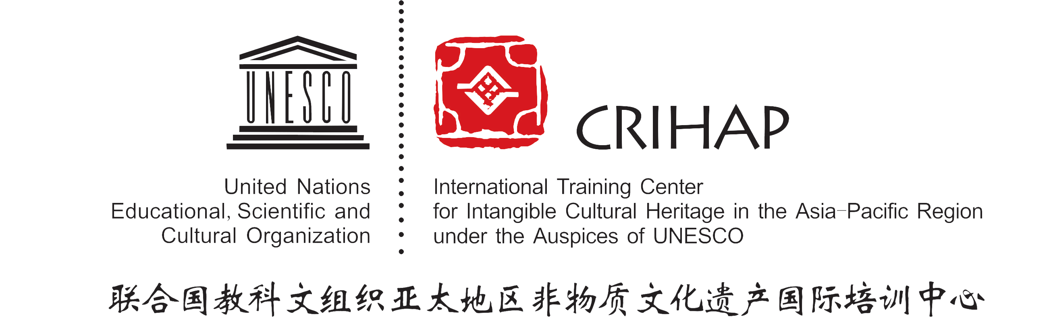
CRIHAP/2013/2.GB/5
Chengdu, 17 June 2013

INTERNATIONAL TRAINING CENTER
FOR INTANGIBLE CULTURAL HERITAGE
IN THE ASIA-PACIFIC REGION UNDER THE AUSPICES OF UNESCO
(CRIHAP)

GOVERNING BOARD

The 2nd Session
Chengdu, China
17 June 2013

Item 5 of the Provisional Agenda
Approval of the Work Plan and Financial Budget of
CRIHAP for 2013

Decision required：paragraph 3

1. In accordance with Article.8.2.c of the Agreement, the Governing Board shall approve the annual work plan and budget of the Centre, including the staffing table.

2. The Work Plan and Budget of CRIHAP for 2013 (June 2013 to February 2014) is contained in the annex.

3．The Governing Board may wish to adopt the following decisions:
DRAFT DECISION GB/5
The Governing Board,
1．Having examined document CRIHAP/2013/2.GB/5 and its annex;
2．Adopts the Work Plan and Financial Budget of CRIHAP for 2013.

Annex
Work Plan and Financial Budget of CRIHAP for 2013

In order to make greater progress and achievement in our work on the basis of the works we have done in 2012, after serious discussion and argument, we drafted, as per the Constitution of CRIHAP and the Medium-Term Development Strategy, the work plan of CRIHAP for 2013 (June 2013 to February 2014). Main contents are as follows:

- International Training:
In order to promote the work which places training at the first place, CRIHAP intends to organize 6 workshops during the period between June 2013 and February 2014. Among them, 4 will be international workshops organized in Beijing, 2 will be international workshops organized in a certain country in the Asia-Pacific Region (one of these 2 workshops is under negotiation).

(1)Workshops in China:
a. June 2013 in Chengdu, Sichuan Province, Workshop on Inventorying under the 2003 Convention at the National Level, with 20 participants from countries and territories of the Pacific region and special zones of Hong Kong and Macau of China;
- October 2013 in Hangzhou, Zhejiang Province, Workshop on the Safeguarding and Present Condition of Traditional Craftsmanship in the Asia-Pacific Region, with 30 participants from the Asia-Pacific Region;
- November 2013 in Yunnan Province, Workshop on Traditional Festivals, with 30 participants from countries and territories which will have participation;
- December 2013 in Zaozhuang, Shandong Province, Workshop on the Ratification of the 2003 Convention, with 20 participants from the Asia-Pacific region;
(2)Workshops abroad:
a. November 2013 in one beneficiary country, Workshop on the Nomination of ICH Elements under the Framework of the 2003 Convention, with 30 participants from culture and art related institutions of provinces and cities of this country.
b. to be determined.

- International conferences:
On the basis of communications, CRIHAP plans:
  - to organize in June 2013 the Chengdu International Conference on Intangible Cultural Heritage in Celebration of the Tenth Anniversary of UNESCO’s Convention for the Safeguarding of the Intangible Cultural Heritage, during the 4th International Festival of the Intangible Cultural Heritage, Chengdu, China;
  - to undertake in September 2013 the ASEAN-China Culture Forum which will be jointly organized by the Ministry of Culture of the People's Republic of China and the Guangxi Zhuang Autonomous Region of the People's Government;
  - to organize in cooperation with China National Center for Safeguarding of Intangible Cultural Heritage, Department of Culture, Zhejiang Province, and the Municipal Government of Hangzhou, the West Lake Expo on Traditional Craftsmanship in the Asia-Pacific Region in October 2013.

- International exchanges and cooperation:
In order to continuously seize the trends of relating UNESCO mechanism and relating international trends in the field of the intangible cultural heritage, CRIHAP plans:
(1) to continue to participate in the 8th Session of the Intergovernmental Committee for the Safeguarding of the Intangible Cultural Heritage of UNESCO;
- to participate in the Meeting of Category II Centers for Intangible Cultural Heritage in the Asia-Pacific Region held in Bulgaria to discuss about the establishment of cooperative mechanism with other C2 centers for the intangible cultural heritage;
- to participate in the 2nd Session of the Governing Board of IRCI, and the 3rd Session of the Governing Board of ICHCAP;
- to organize communicating and cooperating activities for domestic experts and scholars from the Asia-Pacific region, thus, expanding the network for cooperation;
(5) to participate in the 10th Annual Santa Fe International Folk Art Market
- and to participate in the National Workshop on Community-Based Inventorying of Intangible Cultural Heritage in Mongolia.

- Organization Construction:
On the basis of the achievements gained in the past, CRIHAP plans:
  - to hold the 3rd Session of the Governing Board;
  - to hold the 2nd Session of the Advisory Committee;
  - and to continue with the construction of the branch institutions (base).

- Publicity:
CRIHAP will continue to conduct the work for publicity on the basis of organizing activities and will take the initiative to construct the platform for the promotion of publicity. CRIHAP will start the official website construction (2nd stage) in the following period. CRIHAP intends to start the website construction (the 2nd phase), such as to speed up the uploading of the list of ICH and the technical development of the message board, to ensure the integrity of the functions of the website, and to draft the plan for the website promotion.

- Development & Ensuring:
In order to ensure the smooth carrying-out and continuity of the training, CRIHAP intends to do basic research in related fields and to conduct other works for ensuring on the basis of taking capacity-building as the core goal.
  - The research work from June 2013 to February 2014 will mainly focus on the straightening-out and research of and on all the documents of the previous international conferences on the intangible cultural heritage held by UNESCO, as well as the translation and editing of the training materials used by UNESCO for international training.
  - From June 2013 to February 2014, CRIHAP plans to increase staff by way of recruitment, continue to apply for financial funding and resource, as well as offices in order to improve the working condition and to provide guarantee for the professional work.

Financial Budget of CRIHAP in 2013
(RMB Yuan)
Source of funding | Total amount | Remark
Funding from the Chinese government | 6,000,000.00
Items for estimated expenditure | Total amount | Remark
Total estimated expenditure | 6,000,000.00
The 2nd Session of the Governing Board | 400,000.00 | 3 days/30 participants
International Workshops in China | 2,000,000.00 | 4 workshops/ 20-30 participants each
Workshops in the Asia-Pacific Region | 600,000.00 | 2 workshops/ 30 participants each
Chengdu International Conference on Intangible Cultural Heritage in Celebration of the Tenth Anniversary of UNESCO’s Convention for the Safeguarding of the Intangible Cultural Heritage | 800,000.00 | 5 days/200 participants
West Lake Expo on Traditional Craftsmanship in the Asia-Pacific Region | 500,000.00 | 4 days/100 participants
The 2nd Session of the Advisory Committee | 300,000.00 | 3 days/20participants
Participation in the 8th Session of the Intergovernmental Committee for the Safeguarding of the Intangible Cultural Heritage of UNESCO | 200,000.00 | 10 days/4 people
Participation in the 3rd Session of the Governing Board of ICHCAP | 50,000.00 | 3 days/3 people
Participation in the 2nd Session of the Governing Board of IRCI | 60,000.00 | 4 days/3 people
Participation in the Meeting of Category II Centers for Intangible Cultural Heritage in the Asia-Pacific Region held in Bulgaria | 110,000.00 | 5 days/3 people
Participation in the National Workshop on Community-Based Inventorying of Intangible Cultural Heritage in Mongolia | 30,000.00 | 9 days/3 people
Participation in the 10th Annual Santa Fe International Folk Art Market | 300,000.00 | 7 days/6 people
Website Construction (the 2nd Phase) and Material Translation | 100,000.00
Organizing Exchange Activities among ICH Experts in the Asia-Pacific Region | 300,000.00 | 3 times/5 experts each time
Office Expenses | 250,000.00 | Daily operation and OE purchasing

